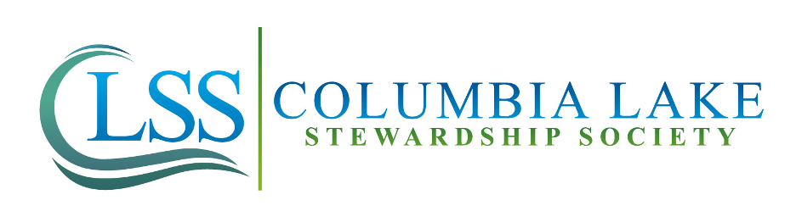

4441 Cedar Bay, Fairmont Hot Springs, BC V0B 1L2

info@columbialakess.ca

**Columbia Lake: Sample Collection and Education Assistant**

**Wage:** $17/hr, an average of 30 hours a week

**Term:** May 8 – August 28, 2023

**Location:** Columbia Valley, BC

**Deadline to Apply:** April 6, 2023

**Eligibility:** In accordance with the Canada Summer Jobs Program, all applicants must be between the age of 15 to 30, a Canadian citizen or permanent resident, and legally allowed to work in Canada.

*\*This position is dependent on program funding\**

The Columbia Lake Stewardship Society (CLSS) is looking for an individual who is passionate about water stewardship to be our Sample Collection and Education Assistant this summer! Please read the job description below and the instructions on how to apply.

**Organization Background:**

CLSS’s mission is to preserve the ecological health and water supply of Columbia Lake for present and future generations through scientific investigation, collaboration, education, and outreach. CLSS achieves this by conducting measurements of water quality parameters, collecting samples, and conducting water quantity measurements, recording data, disseminating information and reporting findings. CLSS shares data and information about the lake with decision-makers and communicates with and encourages others to join in our mission to preserve Columbia Lake’s water resources and natural environment for present and future generations.

The Columbia Lake Stewardship Society began monitoring the water quality and quantity of Columbia Lake in 2014. Since then, we have acquired baseline water quality data, initiated education and outreach projects throughout the Columbia Valley, implemented water quantity monitoring programs, and built relationships and partnerships with community organizations, other water stewardship organizations and the government. The information Columbia Lake Stewardship Society collects helps us understand how residential and human development, climate change, invasive and problematic species and recreational activity may impact the lake. Our work will help improve our community’s knowledge of its water resources and the steps we can take to protect them.

**Job Description:**

Columbia Lake’s Sample Collection and Education Assistant will work alongside scientists, trained citizen scientists and our Executive Director. The successful candidate will assist with the collection of water quality samples and measurements, water quantity measurements, provide educational materials to community members and tourists through community outreach programs, participate in and promote our conservation initiatives, and assist in delivering educational summer camps for kids. The Assistant will average 30 hours weekly, with some evening and weekend shifts required.

**Duties and Responsibilities:**

* Conduct lake and stream water quality monitoring, including preparation, equipment maintenance, field sampling, and data entry;
* Work with volunteers and ensure consistency and accuracy in water quality monitoring procedures on the lake during sampling days;
* Assist in the collection of water quantity measurements ;
* Educate homeowners and visitors about good shoreline practices, good boating practices, and how to prevent the spread of invasive species;
* Help with the management and analysis of water quality and quantity data;
* Assist in the preparation and hosting of community events;
* Assist with delivering educational kid's camps at various lakeside communities; and
* Assist in maintaining communications via email, Facebook and our website.

**Required** **Qualifications:**

* Self-motivated
* Strong interest in the environment and science
* Passion for water stewardship
* Strong public communication skills
* Ability to work independently and with a team
* Secured housing in the Columbia Valley
* Ability to complete computer work from home and commute to various locations around the lake
* Must be able to provide a Vulnerable Sector Check (necessary when dealing with children)

**Additional Desired Qualifications:**

* Be enrolled in a post-secondary education program related to environmental science, environmental studies, biology, environmental resource management, geography or a similar field;
* Have a valid driver's license and access to a personal vehicle; and
* Hold a Pleasure Craft Operator Card.

**To apply:**

Please send a cover letter and resume to:

Caily Craig, Executive Director

[info@columbialakess.ca](mailto:info@columbialakess.ca)

We appreciate your interest in working for the Columbia Lake Stewardship Society.